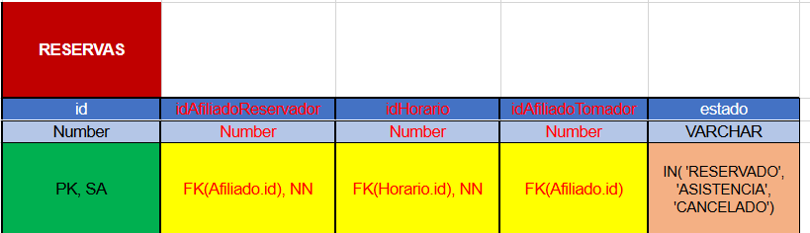CAMBIOS EN LAS TABLAS

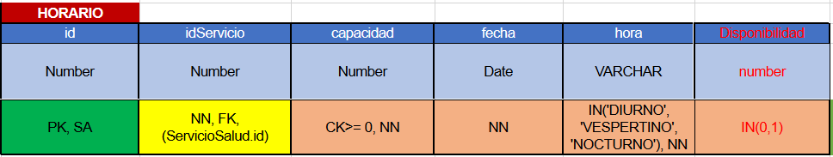

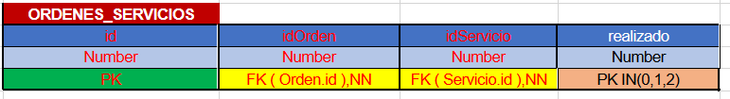

SQL METADATOS:

SELECT A.TABLE_NAME AS NOMBRETABLA, MAX(COLUMN_ID)AS NUMCOLUMNAS, SUM(CASE WHEN NULLABLE='Y' THEN 1 ELSE 0 END) AS NUMCOLSNULL, B.FK AS NUMCOLSFKS

FROM ALL_TAB_COLUMNS A LEFT OUTER JOIN

(SELECT TABLE_NAME,COUNT(R_OWNER) AS FK

FROM ALL_CONSTRAINTS

GROUP BY TABLE_NAME) B

ON A.TABLE_NAME = B.TABLE_NAME

GROUP BY A.TABLE_NAME,B.FK

ORDER BY A.TABLE_NAME;